
Moodlakatte Institute of Technology
Women Empowerment Cell
TOPIC
"Empowering Change: Raising Awareness for Anti-Sexual Harassment in Today's Society"
Organized On
Date:17^{t/h} June 2022
Venue: Auditorium

Resource Person
Akshatha Naik
Contact Details
Contact No:9448767531

Participants
Branch/ Section: Ist Year B.E Students

Preamble

In pursuit of fostering a society free from the shadows of sexual harassment, we, the organizers and participants of this awareness program, gather with unwavering determination to address and combat this pressing issue head-on. Recognizing the significance of "Empowering Change: Raising Awareness for Anti-Sexual Harassment in Today's Society," we unite under the shared belief that every individual deserves to live and thrive in an environment that is respectful, safe, and free from any form of harassment. With empathy and solidarity as our guiding beacons, we pledge to utilize this platform to enlighten, educate, and empower our communities about the grave consequences of sexual harassment and the vital importance of standing against it collectively. By fostering understanding, promoting consent, and encouraging open dialogue, we strive to create a transformative movement that emboldens survivors, challenges societal norms, and holds perpetrators accountable. Through our unwavering commitment to this cause, we aim to sow the seeds of change and cultivate a future where respect, dignity, and equality flourish for all individuals, paving the way for a brighter, more harmonious society.

BRIEF PROFILE OF THE CHIEF GUEST:

Mrs Akshatha Naik is Assistant professor in the department of ECE and a chairperson of ICC
REPORT
The "Empowering Change: Raising Awareness for Anti-Sexual Harassment in Today's Society" initiative brought together passionate individuals to combat sexual harassment through workshops, discussions, and awareness campaigns. By promoting consent education, supporting survivors, and advocating for policy changes, the program fostered a safer and more respectful environment. Participants became more proactive in identifying and intervening in instances of harassment, and the initiative left a lasting impact on both individuals and the broader community, spurring a collective commitment to uphold equality and dignity Vice Principal Prof. Melvin de Souza, Head of the Department Professor Balanageshwar, Head of the Department of Artificial Intelligence Professor Varunakumar, staff, students were present. Professor Sushma Shetty welcomed, student Sinchana Devadiga delivered vote of thanks, Fatima narrated.

ORGANIZING COMMITTEE
Staff co-coordinators
Mrs. Akshatha Naik
Mrs. Pavana

Student Coordinators:
Mr. Fathima 3rd Sem ECE
Mr. Sinchana Devadiga 3rd Sem ECE

FEEDBACK
Resource person: The program was well planned and properly executed. The response from students was good.

Students and Parents: The program was highly interactive and effective.

Photos
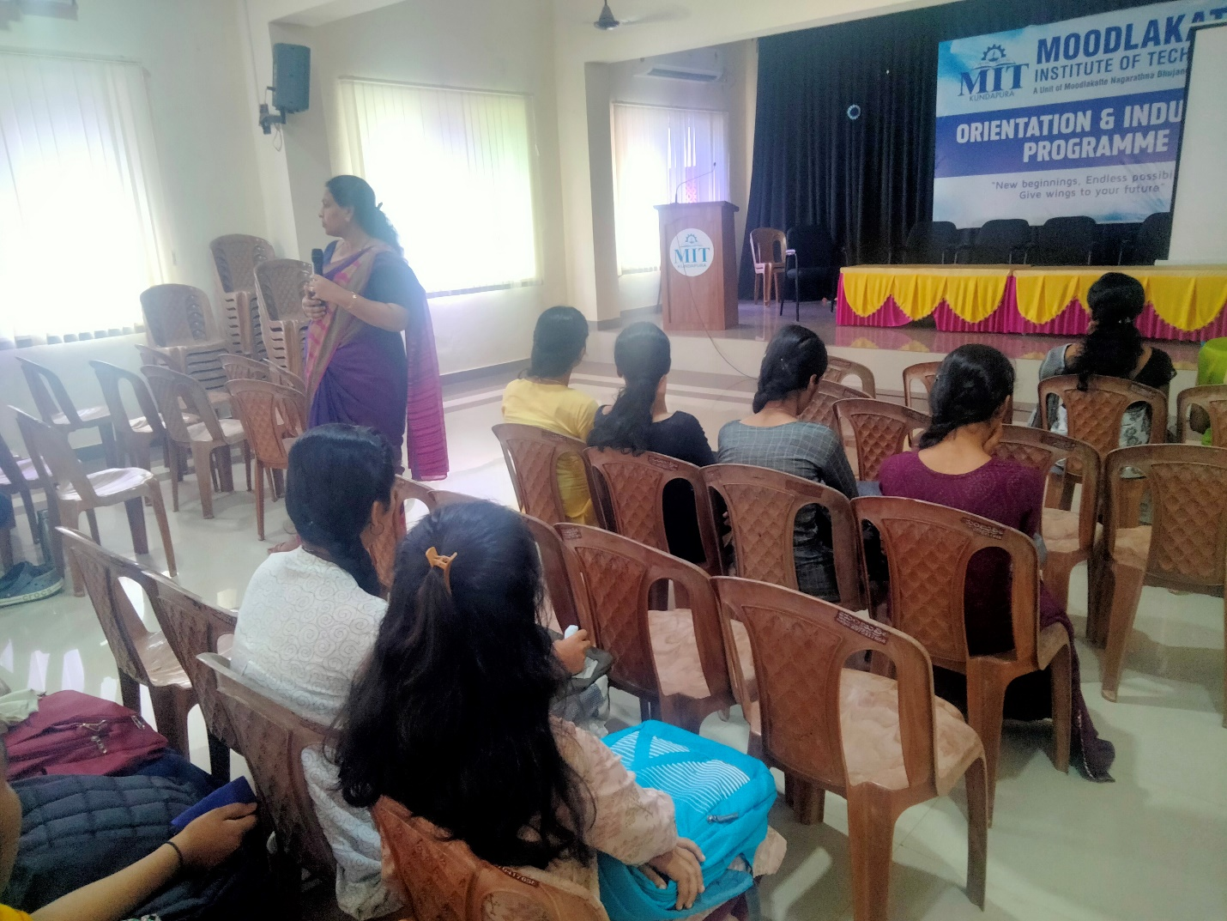

Signature/Seal of the HOD/Principal

