
Moodlakatte Institute of Technology
TRAINING AND PLACEMENT CELL

TOPIC
HONEYWELL Centre of Excellence for Youth Empowerment -UIPATH RPA ASSOCIATE
Organized On
Date: 06/Dec/2022
Venue: Auditorium

Resource Person
Mr. Vinod Bhat- Accenture Sr. Automation Engineer
Mr. Kishore- Amiseq Sr. Automation Engineer
Contact Details
Phone No:
Mr. Kishore -9741569378
Mr.Vinod Bhat - 9740871408

Participants
Branch/ Section: 7th Semester ECE and CSE Students
Number of Students: 85

Preamble
In today's dynamic business landscape, organizations are continuously seeking innovative ways to streamline processes, improve efficiency, and achieve strategic objectives. RPA has emerged as a powerful solution that empowers businesses to automate repetitive and rule-based tasks, enabling human resources to focus on higher-value activities and driving overall operational excellence. This training program has been thoughtfully crafted to provide students with the necessary knowledge, skills, and practical insights to navigate the world of RPA effectively. Whether students are new to automation or have prior experience, this program will equip them with the tools and techniques required to harness the full potential of RPA and drive tangible results within your organization.

BRIEF PROFILE OF TRAINER
Kishore- Amiseq- Sr. Automation Engineer
Professional Summary:
• Having 7.5+ years of experience in IT, which includes 4+ years of experience in RPA implementation using Automation
Anywhere and Intellibot.
• Expertise in RPA processes, including requirements gathering, solution designing, coding, testing, debugging,
documentation and implementation using different tools such as Automation Anywhere and Intellibot.
• Experiencing in project management methodology Agile (Scrum).
• Experience in providing training to development teams on how to track, plan and analyze using JIRA.
• Experience in the task recording, editing, and scheduling and distribution using Automation Anywhere
• Experience in Robotic Process Automation Tool Automation Anywhere to automate web applications, windows-based
applications using Object Cloning, Manage Windows Controls, PDF integration, String Operations, Excel etc.
• Extensively worked with commands like object cloning, web recorder, Excel, Database, Terminal Emulator commands
etc.
• Strong experience on various commands String Operations, CSV command, Error Handling, Delay and Wait
commands, Object Cloning and Manage Web Controls, Loop Command, if/else commands.
• Having good knowledge on Meta bots and Basic knowledge on IQ Bots.
• Developing and Maintaining Test Scripts, analyzing bugs and communicate with development team members in fixing
the defects & generation of bug report.
• Designed solutions utilizing RPA best practices and maintain technical responsibility for project delivery.
• Worked closely with Process SME's to translate process in to detailed design documents and educated SME's to work
with Bots in production.
• Automating data transfers, including importing/exporting data between applications or files.
• Automation Anywhere certified developer.
• Having Good Knowledge of Python,G1ANT,OpenBots and Machine Learning Concepts.
Technical Skills:
RPA Tools Automation Anywhere 9.x, 10.x, 11.x and Intellibot, G1ANT,

REPORT
The following report outlines the details and outcomes of a 100-hour training program conducted for 95 final year engineering students from the Computer Science and Engineering (CSE) and Electronics and Communication Engineering (ECE) branches. The training program was organized and sponsored by Honeywell, a leading technology company. The focus of the training program was on developing skills in UI Path, a popular robotic process automation (RPA) tool.
Objectives:
The primary objectives of the training program were as follows:
- To equip the students with practical knowledge and skills in UI Path.
- To enhance their understanding of robotic process automation (RPA) concepts.
- To provide hands-on experience in designing and implementing automation solutions using UI Path.
- To prepare the students for potential career opportunities in the field of RPA.
Training Details:
Duration: The training program spanned 100 hours, divided into theoretical sessions, hands-on labs, and practical assignments.
Participants: 95 final year engineering students, comprising 50 students from the CSE branch and 45 students from the ECE branch.
Trainers: Experienced trainers , specialized in UI Path and RPA technologies.
Sponsorship: The training program was sponsored by Honeywell, covering the training expenses, training materials, and certificates.
Training Curriculum:
- Introduction to RPA and its applications.
- Overview of UI Path and its components.
- UI Path Studio: Interface, activities, and workflows.
- Automating tasks using UI Path.
- Data manipulation and handling.
- Error handling and exception handling.
- UI Path Orchestrator: Deployment and management of automation processes.
- Best practices and advanced features in UI Path.
Training Methodology:
The training program followed a blended learning approach, combining theoretical sessions, hands-on labs, and practical assignments. The participants were provided with access to UI Path Studio, enabling them to practice and implement automation solutions. The trainers facilitated interactive discussions, demonstrations, and Q&A sessions to ensure a comprehensive understanding of the concepts and tools.
Assessment and Certification:
At the end of the training program, an assessment was conducted to evaluate the participants' understanding and practical skills in UI Path. The assessment consisted of both theoretical and practical components. Upon successful completion of the assessment, all 95 students received certificates of achievement from Honeywell, validating their proficiency in UI Path.
Outcomes and Benefits:
Enhanced Skills: The training program equipped the participants with practical skills in UI Path, enabling them to automate business processes and enhance their employability in the field of RPA.
Industry-Relevant Knowledge: The participants gained a solid understanding of RPA concepts and best practices, preparing them for real-world automation projects.
Certification: The certificates awarded by Honeywell serve as a valuable recognition of the participants' proficiency in UI Path, enhancing their resumes and career prospects.
Industry Collaboration: The sponsorship by Honeywell strengthened the industry-academia collaboration, providing students with exposure to a leading technology company and potential career opportunities.
ORGANIZING COMMITTEE
Prof. Amruthmala
Prof. Akshatha Naik
Prof. Sookshma Adiga
Prof. Asha Kumari
Prof. Pramila Billava
FEEDBACK
Students: The participants' feedback regarding the training program was overwhelmingly positive, highlighting the trainers' expertise, the relevance of the curriculum, and the hands-on approach.

Resource Person: The students exhibited a high level of enthusiasm and actively participated in the training sessions. They showed a genuine interest in learning UI Path and grasped the concepts quickly. The students exhibited a high level of motivation and dedication throughout the training program. They were proactive in seeking clarification, practicing independently, and taking initiative in exploring additional resources.

PHOTOS AND NEWS

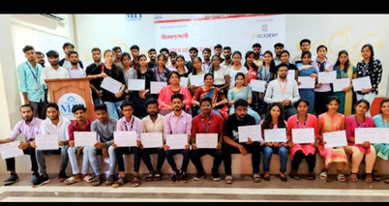 | 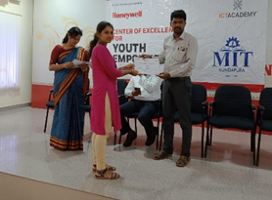
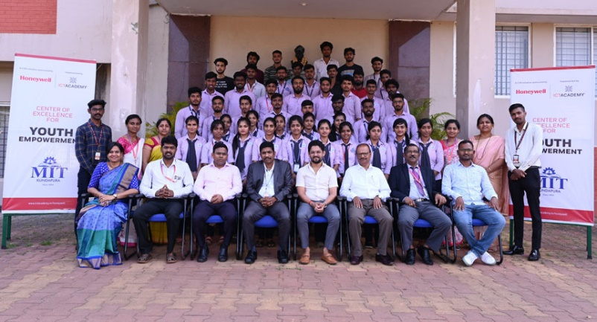 | 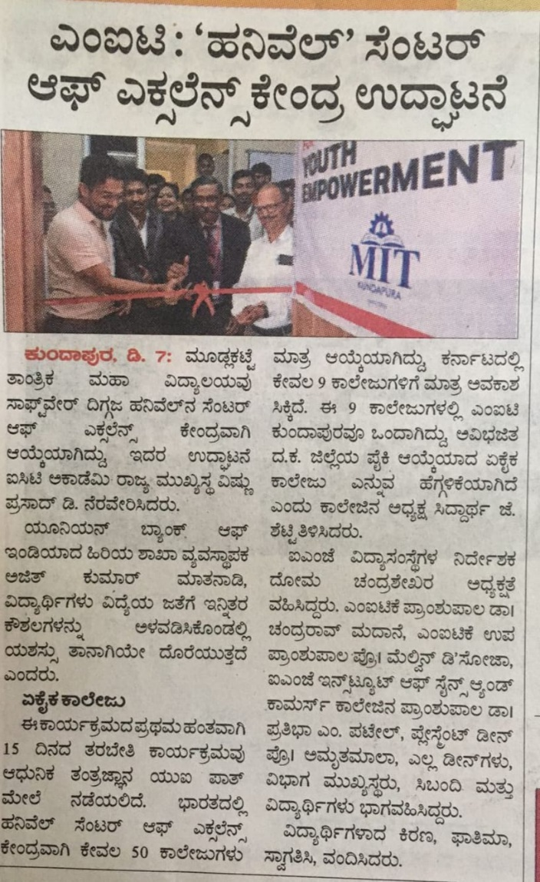

_________________________________________________________________________________
Dean TPIR Principal

