\


Moodlakatte Institute of Technology
TRAINING AND PLACEMENT CELL
TOPIC
Grow With Google - Google Certification Program
Organized On
13-12-2022
Resource Person
Mr Ganesh
Sr. Trainer - Impact Programs
Ethnus

Contact Details
Phone No:
Mobile: +91 9019921342
ganesh.naik@ethnus.com

Participants
Branch/ Section:
1st and second year BE students
2nd Year MBA students

Preamble
Grow with Google certifications can help engineering and MBA students to showcase their expertise, improve their job prospects, and potentially gain a competitive edge in the technology industry.
REPORT
The Google Certification Program offers various certifications that can be beneficial for engineering students looking to enhance their skills and advance their careers in the technology industry. The certification Program has been funded by NASSCOM in association with ETHNUS
Training & Certification Objectives:
- The Google Certification Program aims to equip students with in-demand digital skills relevant to various fields such as advertising, data analysis, cloud computing, web development, and more.
- Industry Recognition: Google certifications are recognized and respected in the industry. By earning a Google certification, students can demonstrate their proficiency and expertise in specific areas, which can boost their credibility and increase their chances of employment or career advancement.
- Career Advancement: The program aims to help students enhance their career prospects by providing them with the skills and credentials that employers seek. Google certifications can open doors to job opportunities, internships, or freelance work, as they serve as evidence of a student's competence and commitment to continuous learning.
- Networking and Community Engagement: The Google Certification Program often includes access to a community of certified professionals, allowing students to connect with like-minded individuals, industry experts, and potential mentors. Engaging with this network can provide valuable insights, collaborations, and career guidance.
- Personal Growth and Confidence: By successfully completing a Google certification, students gain confidence in their abilities and feel more empowered in their chosen field. The program encourages students to take ownership of their learning journey and fosters a growth mindset.
- Stay Updated with Industry Trends: Google certifications often require individuals to stay up-to-date with the latest industry trends, technologies, and best practices. The program helps students develop a habit of continuous learning, ensuring they remain relevant in a rapidly evolving digital landscape.
Participants:
296 First and Second Year Engineering and First Year MBA Students participated in the certification program.
Event Highlights:
Google Cloud Certifications: These certifications validate expertise in Google Cloud Platform (GCP) and cover various roles and specializations, such as cloud architecture, data engineering, machine learning, and more. GCP certifications can be valuable for engineering students interested in cloud computing and infrastructure.
Google Ads Certifications: These certifications focus on advertising and cover different aspects of Google Ads, including search, display, video, shopping, and measurement. They can be relevant for engineering students interested in digital marketing, e-commerce, or working with online advertising platforms.
Google Analytics Certifications: These certifications demonstrate proficiency in using Google Analytics to analyze website traffic, track user behavior, and derive insights to optimize online performance. They can be beneficial for engineering students interested in data analysis, web analytics, or digital marketing.
Benefits and Outcomes:
- Enhanced Job Prospects: Google certifications are recognized and respected in the industry.
- Credibility and Professional Recognition: Google certifications provide a credible validation of your skills and knowledge.
- Expanded Skill Set: The Google Certification Program equips individuals with practical skills and knowledge relevant to the digital landscape.
- Access to Exclusive Resources: Google certifications often come with access to exclusive resources, tools, and updates.
- Professional Networking: The Google Certification Program provides opportunities for networking with a community of certified professionals.
- Personal Growth and Confidence: Successfully completing a Google certification program can boost your confidence in your abilities and contribute to personal growth.
- Continuous Learning and Skill Upgrading: Google certifications often require individuals to maintain their knowledge and skills through ongoing learning and recertification.
ORGANIZING COMMITTEE
Prof.Amruthmala-Dean TPIR
Prof.Akshatha Naik-Placement Officer
Prof.Kavya -Placement C0-ordiantor
FEEDBACK
Students perceived value and recognition of the certification in the industry or job market. Overall a positive feedback was provided by the student

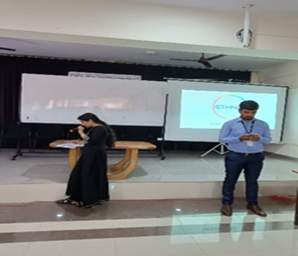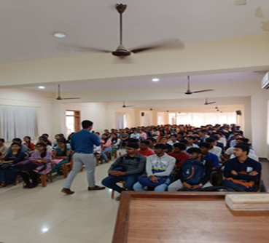
Trainer Feed Back
Dear Ma'am,

Greetings from Ethnus!

THANK YOU VERY MUCH for giving me an opportunity to conduct Grow With Google - Google Certification Program in your college. It was a great experience to interact with a large number of students for two days. Students were highly disciplined, punctual and patient during the program. Their interest towards the course made them to complete the certification very quickly. This response encouraged me to bring more useful programs for your students in the coming days.

THANKS AGAIN for your support and the hospitality in making the program successful.

Please convey my gratitude to the management and all the students well.

Thanks and Regards,
Ganesh Naik
Sr. Executive - Impact Programs
Ethnus
Mobile: +91 9019921342
ethnus.com | codemithra.com

_____________________________________________________________________________
Dean TPIR Principal

